🛒 MISSALPHA™ QUICKCART

AI Coding Agents Masterclass —
One project → one workflow → one tool for each responsibility.

Project
AI-Powered Quick-Commerce E-Commerce Website
React
+
Python FastAPI
+
PostgreSQL
+
LLM API
+
AI Coding Agent
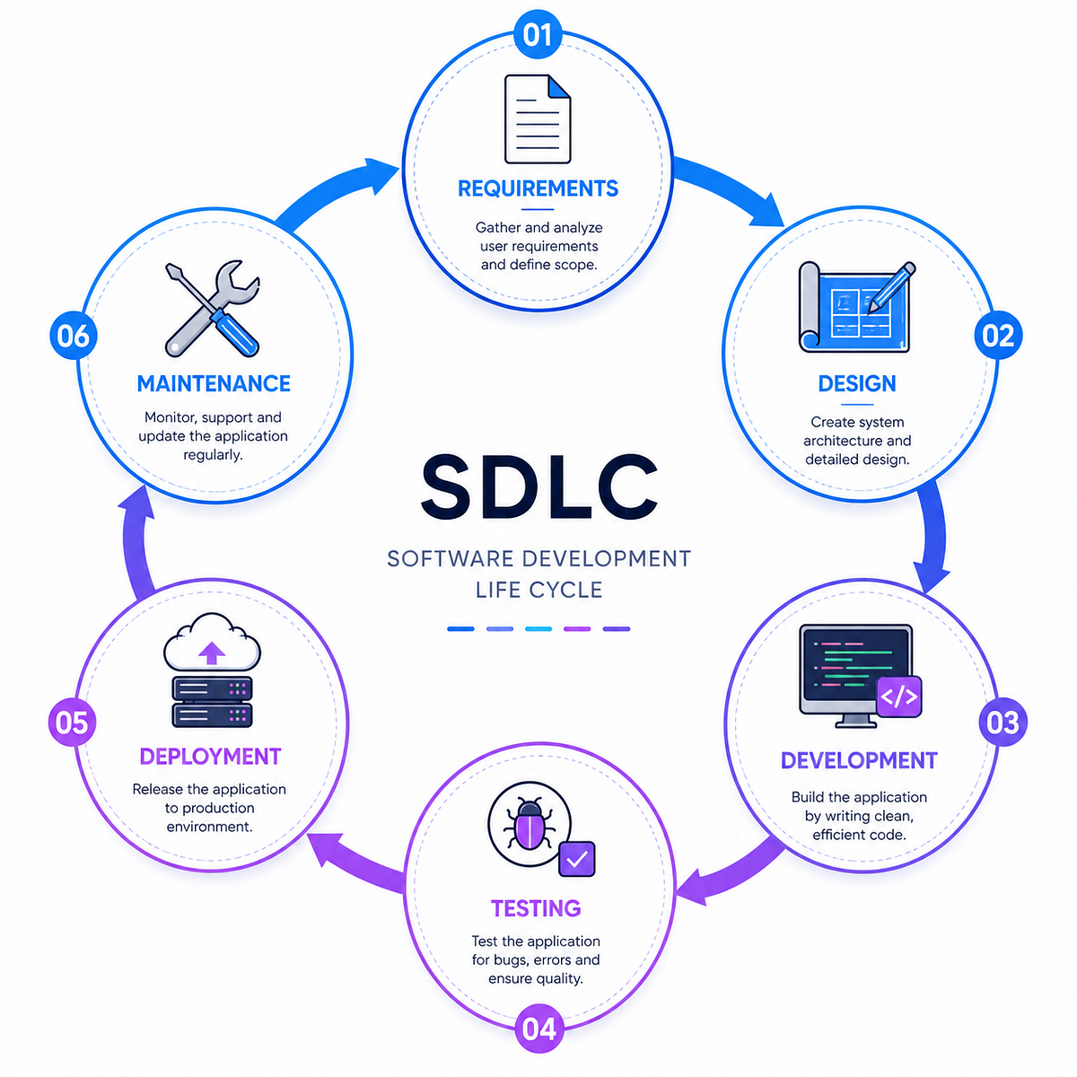
The project grow like this:
💡 IDEA
↓
🧠 REQUIREMENTS
↓
🏗️ ARCHITECTURE
↓
📋 PLAN
↓
🎨 REACT FRONTEND
↓
🐍 PYTHON BACKEND
↓
🗄️ DATABASE
↓
🔌 API INTEGRATION
↓
🤖 AI FEATURE
↓
🐛 DEBUG
↓
🧪 TEST
↓
🔍 REVIEW
↓
🔐 SECURE
↓
🚀 DEPLOY


1. WHAT EACH AI TOOL DOES
Tool | What it does | Simple explanation
🧠 ChatGPT | Planning, explanation, requirements | Think with me
🧠 Claude | Architecture, reasoning, review | Analyze with me
💻 Cursor Agent | Build, edit, run, debug | Build with me
💻 Claude Code | Terminal-based coding agent | Work on my codebase
💻 OpenAI Codex | Software engineering tasks | Complete coding tasks
🧑‍💻 GitHub Copilot | Coding assistance + GitHub workflows | Assist while coding
🧪 Postman | API testing | Test my APIs
🗃️ PostgreSQL | Database | Store my data
🔀 Git/GitHub | Version control | Save and track my code
🤖 LLM API | AI inside application | Make my app intelligent

ChatGPT → Cursor Agent → Postman → GitHub → LLM API
Keep Claude Code and Codex as alternatives rather than switching between five coding agents during the live build.
Your source plan similarly identifies Cursor Agent as the primary agent and Claude Code/Codex as alternatives.

WHO DOES WHAT?
CHATGPT / CLAUDE
↓
THINK + PLAN + EXPLAIN

↓

CURSOR AGENT
↓
BUILD + EDIT + RUN + DEBUG

↓

POSTMAN
↓
TEST APIs

↓

GITHUB
↓
VERSION CONTROL

↓

LLM API
↓
ADD AI TO THE APPLICATION

↓

HUMAN
↓
REVIEW + APPROVE + DECIDE


Now Let’s START THE QUICKCART PROJECT

TASK 1 — THINK BEFORE YOU CODE

Goal
Understand the business problem.

AI TOOL
🟢 ChatGPT

Why?
Because at this stage we don't need an AI coding agent.
We need thinking and planning.

STEP 1.1 — IDEA

Idea
Build a modern grocery quick-commerce platform with an AI shopping assistant.

STEP 1.2 — REQUIREMENTS

Tool: ChatGPT
Prompt:
Act as a Senior Product Manager.

We are building an AI-powered quick-commerce
platform called QuickCart.

Users should be able to:

- Browse grocery products
- Search products
- Filter categories
- View product details
- Add products to cart
- Update quantity
- Remove products
- Proceed toward checkout
- Use an AI shopping assistant

Target users:

- College students
- Working professionals
- Families
- Everyday grocery shoppers

Create a simple Product Requirements Document.

Include:

1. Problem
2. Target users
3. User personas
4. Features
5. User stories
6. Functional requirements
7. Non-functional requirements
8. MVP
9. Future features
10. Acceptance criteria

Do NOT write code.

 We learnt here :
IDEA
↓
REQUIREMENTS


STEP 1.3 — ARCHITECTURE

Tool: ChatGPT / Claude
Prompt:
Act as a Senior Full-Stack Architect.

Using the approved QuickCart requirements,
design the application architecture.

Frontend:
React + Tailwind CSS

Backend:
Python + FastAPI

Database:
PostgreSQL

AI:
LLM API

Development:
Git + GitHub

API Testing:
Postman

Show:

1. System architecture
2. Frontend architecture
3. Backend architecture
4. Database entities
5. API structure
6. AI architecture
7. Authentication
8. Security
9. Folder structure

Explain everything in beginner-friendly language.

Do not write implementation code.


STEP 1.4 — CREATE THE DEVELOPMENT PLAN

Tool: 🟢 Cursor Agent — Plan Mode
Now we move from thinking to agentic development.
Cursor's planning capability is useful here because the agent can plan complex multi-file work before implementation.

Prompt
You are the AI Coding Agent for QuickCart.

Do NOT start coding yet.

First create an implementation plan.

Break the project into:

1. Project setup
2. React storefront
3. Product catalog
4. Search
5. Filtering
6. Cart
7. FastAPI backend
8. PostgreSQL database
9. Frontend-backend integration
10. AI Shopping Assistant
11. Testing
12. Security
13. Deployment

For each step provide:

- Goal
- Files affected
- Dependencies
- Implementation steps
- Validation
- Possible risks

Wait for approval before implementation.
"The agent is not coding yet. It is planning."

🎨 TASK 2 — BUILD THE FRONTEND

STEP 2.1 — CREATE REACT APPLICATION

Tool
🟢 Cursor Agent

Technologies
- React
- Tailwind CSS
Prompt:
Act as a Senior React Developer.

Implement the QuickCart frontend.

Before coding:

1. Inspect the project.
2. Review the existing structure.
3. Identify files to create/change.
4. Create an implementation plan.

Then build:

- Header
- Search bar
- Location selector
- Categories
- Promotional banner
- Product cards
- Product grid
- Cart indicator
- Footer

Use reusable React components.

Use original QuickCart branding.

Requirements:

- Responsive
- Accessible
- Clean component structure
- Loading states
- Empty states

After implementation:

1. Run the application.
2. Check for errors.
3. Fix errors.
4. Summarize changes.

Now see:
EMPTY FOLDER
↓
REACT
↓
QUICKCART UI


STEP 2.2 — ADD INTERACTION

Tool
🟢 Cursor Agent
Don't create a new prompt from scratch.
Continue the same agent session.
Now implement the next frontend milestone.

Add:

1. Product search
2. Category filtering
3. Price sorting
4. Discount badges
5. Quantity controls
6. Add to cart
7. Cart count
8. Empty cart
9. Loading state
10. Mobile navigation

Important:

- Inspect existing code first.
- Reuse components.
- Do not rewrite working functionality.
- Make incremental changes.
- Run the application.
- Fix errors.
One prompt = one meaningful development increment.

🐍 TASK 3 — BUILD THE BACKEND
"Frontend is what users see. Backend is where application logic lives."

STEP 3.1 — FASTAPI

Tool
🟢 Cursor Agent

Technology
Python + FastAPI
Prompt:
Act as a Senior Python Backend Engineer.

Build the QuickCart backend using:

Python + FastAPI.

Create modules for:

- Products
- Categories
- Cart
- Users
- Orders

Create APIs:

GET /api/products
GET /api/products/{id}
GET /api/categories
POST /api/cart/items
GET /api/cart
PATCH /api/cart/items/{id}
DELETE /api/cart/items/{id}

Use:

- Pydantic
- Routes
- Schemas
- Services
- Database layer
- Validation
- Error handling
- Proper HTTP status codes
- CORS
- Environment variables
- API documentation

First inspect the project.

Implement incrementally.

Then:

- Start the server.
- Test APIs.
- Fix errors.


🗄️ STEP 3.2 — DATABASE

Tool
🟢 Cursor Agent

Technology
PostgreSQL
Prompt:
Implement the QuickCart PostgreSQL database.

Entities:

User
Category
Product
Cart
CartItem
Order
OrderItem

Create:

- Primary keys
- Foreign keys
- Relationships
- Validation
- Useful indexes

Create realistic grocery seed data.

Verify:

1. Database connection
2. Database setup
3. CRUD operations
4. Backend integration

Never store passwords or API keys in plain text.
The source project plan uses these same core entities and database responsibilities.

🔌 STEP 3.3 — CONNECT FRONTEND + BACKEND

Tool
🟢 Cursor Agent
Prompt:
Act as a Senior Full-Stack Engineer.

Connect the QuickCart React frontend
to the FastAPI backend.

Replace static product data with API data.

Implement:

1. Fetch products
2. Fetch categories
3. Search
4. Add to cart
5. Retrieve cart
6. Update quantity
7. Remove item
8. Loading state
9. Error state
10. Empty state

Requirements:

- Create reusable API service functions.
- Keep API logic separate from UI.
- Use environment variables.
- Handle network errors.
- Do not hardcode localhost throughout components.

Run frontend and backend.

Verify the complete flow.

Now see:
 REACT
↓
HTTP REQUEST
↓
FASTAPI
↓
BUSINESS LOGIC
↓
POSTGRESQL
↓
JSON RESPONSE
↓
REACT
"Now our UI is connected to real software infrastructure."

🧪 STEP 3.4 — TEST THE APIs

Tool
🟠 Postman
This is important:
Don't use AI for everything.
See that professional developers use specialized tools.
Test:
GET /products
GET /categories
POST /cart/items
GET /cart
PATCH /cart/items
DELETE /cart/items
Cursor builds the API. Postman verifies the API.

🤖 TASK 4 — ADD AI INTELLIGENCE
Now we make QuickCart genuinely AI-powered.

Tool Map
Job | Tool
Design AI feature | ChatGPT / Claude
Implement AI backend | Cursor Agent
Build AI UI | Cursor Agent
AI reasoning | LLM API
Product data | PostgreSQL
Validation | FastAPI
Testing | Postman + automated tests

STEP 4.1 — DESIGN AI FEATURE

Tool
🟢 ChatGPT / Claude
Ask:
Design an AI Shopping Assistant for QuickCart.

Users can ask:

"Breakfast for 3 people under ₹500."

"Vegetarian dinner for 4 people."

"Healthy snacks under ₹300."

Design:

1. User experience
2. AI workflow
3. Backend architecture
4. API endpoint
5. Input schema
6. Output schema
7. Product matching
8. Budget handling
9. Validation
10. Failure handling

Important:

AI must not invent:

- Products
- Prices
- Product IDs
- Stock

Products must come from our database.

Return structured JSON.

Do not implement yet.


STEP 4.2 — BUILD AI BACKEND

Tool
🟢 Cursor Agent
Implement:

POST /api/ai/shopping-assistant

Input:

{
"query": "breakfast for 3 people under 500",
"preferences": {
"diet": "vegetarian"
}
}

Workflow:

1. Validate request.
2. Retrieve relevant products from PostgreSQL.
3. Send relevant product information to the LLM.
4. Ask the LLM to recommend only supplied products.
5. Require structured JSON.
6. Validate AI response.
7. Reject unknown products.
8. Calculate totals using database prices.
9. Return recommendations.
10. Handle AI/API failures.

The database is the source of truth.

Never trust AI for:

- Product price
- Product ID
- Stock
- Final total

Add tests.
"AI recommends. Our application validates."

STEP 4.3 — BUILD AI FRONTEND

Tool
🟢 Cursor Agent
Prompt:
Create an AI Shopping Assistant
inside the QuickCart React application.

Add:

- Chat interface
- User message
- AI response
- Suggested prompts
- Recommended products
- Product price
- Quantity
- Add to cart
- Loading state
- Error state

Suggested prompts:

"Breakfast for 3 under ₹500"

"Vegetarian dinner for 4"

"Healthy snacks under ₹300"

Use actual product information
returned by our backend.

Allow recommended products
to be added to the cart.

Do not redesign unrelated features.


🤩 THE WOW MOMENT
"I need a vegetarian dinner for 4 people under ₹500."
watch:
USER
↓
NATURAL LANGUAGE
↓
AI
↓
PRODUCT DATABASE
↓
MATCHING
↓
RECOMMENDATION
↓
VALIDATION
↓
PRODUCT CARDS
↓
ADD TO CART
"Now We have moved from AI-generated code to an AI-powered application."

🐛 TASK 5 — DEBUG WITH AN AI CODING AGENT

Tool
🟢 Cursor Agent
Introduce a controlled bug.
Example:
Wrong API endpoint
↓
404 Error
Then:
Act as a Senior Debugging Engineer.

Here is the error:

[PASTE ERROR]

Affected feature:
[FEATURE]

Expected:
[EXPECTED]

Actual:
[ACTUAL]

Do not immediately rewrite the code.

First:

1. Find root cause.
2. Explain the problem.
3. Identify affected files.
4. Propose smallest safe fix.
5. Implement the fix.
6. Run the relevant test.
7. Verify the original functionality.

Do not modify unrelated code.

Student learns:
ERROR
↓
ROOT CAUSE
↓
FIX
↓
TEST
↓
VERIFY


🧪 STEP 5.2 — TEST THE APPLICATION

AI Tool
🟢 Cursor Agent

Testing tools
🟠 Postman
🟠 Pytest / frontend test framework
Prompt:
Act as a Senior QA Engineer.

Create a QuickCart testing strategy.

Test:

PRODUCTS
- Loading
- Search
- Filtering
- Invalid product

CART
- Add
- Increase quantity
- Decrease quantity
- Remove
- Empty cart
- Invalid quantity

API
- Invalid request
- Missing fields
- Server error

AI
- Valid query
- Empty query
- Budget limit
- No matching products
- Very long query
- Invalid AI response
- AI service unavailable

For each test provide:

Test ID
Scenario
Input
Expected result
Priority

Then implement the highest-priority tests.

"Code generated ≠ Code verified."

🔍 STEP 5.3 — CODE REVIEW

Tool
🟢 Cursor Agent / Claude Code
Act as a Senior Software Engineer.

Review the entire QuickCart project.

Inspect:

- React
- FastAPI
- Database
- APIs
- AI integration
- Authentication
- Validation
- Error handling
- Environment variables

Look for:

- Bugs
- Security issues
- Hardcoded secrets
- Duplicate code
- Poor API design
- Missing validation
- AI hallucination risks
- Performance problems

Categorize:

CRITICAL
HIGH
MEDIUM
LOW

Do not modify code.

Give:

Location
Problem
Impact
Recommended fix

"AI can review code, but the developer decides whether the change should be accepted."

🔐 STEP 5.4 — SECURITY

Tool
🟢 Cursor Agent / Claude Code
Perform a security review of QuickCart.

Check:

- API keys
- Git secrets
- Environment variables
- SQL injection
- XSS
- CORS
- Authentication
- Authorization
- AI permissions
- Prompt injection
- Untrusted AI output
- Data leakage
- Dependency vulnerabilities

For every issue provide:

Risk
Evidence
Impact
Mitigation

Never print secret values.

Do not make destructive changes.

Create a security remediation plan.
Your existing masterclass framework emphasizes protecting Code + Data + Tools + Secrets, with a human checkpoint before execution.

🚀 STEP 5.5 — DEPLOYMENT

Tool
🟢 Cursor Agent

Supporting tools
Git → GitHub → CI/CD → Hosting
Prompt:
Act as a Senior DevOps Engineer.

Prepare QuickCart for production deployment.

Review:

- React frontend
- FastAPI backend
- PostgreSQL
- Environment variables
- API configuration
- CORS
- Build process
- Logging
- Error handling

Create:

1. Production environment template
2. Frontend build configuration
3. Backend deployment configuration
4. Database checklist
5. Production CORS configuration
6. Health-check endpoint
7. Deployment checklist
8. Git workflow
9. CI/CD recommendation
10. Rollback plan

Do not deploy automatically.

Identify everything that requires human approval.
Then:
CODE
↓
GIT
↓
GITHUB
↓
CI/CD
↓
DEPLOY
↓
USERS


🗺️ COMPLETE ROADMAP

🛒 BUILD QUICKCART WITH AI
# | Step | AI Agent / Tool | Technology | Student Outcome
01 | 💡 Idea | ChatGPT | — | Understand problem
02 | 📋 Requirements | ChatGPT | PRD | Define product
03 | 🏗️ Architecture | ChatGPT / Claude | System design | Design solution
04 | 📅 Planning | Cursor Agent | Plan Mode | Break project
05 | 🎨 Frontend | Cursor Agent | React | Build UI
06 | ✨ UI Features | Cursor Agent | React | Search + Cart
07 | 🐍 Backend | Cursor Agent | FastAPI | Build APIs
08 | 🗄️ Database | Cursor Agent | PostgreSQL | Store data
09 | 🔌 Integration | Cursor Agent | REST API | Connect systems
10 | 🧪 API Testing | Postman | REST | Verify APIs
11 | 🤖 AI Design | ChatGPT / Claude | AI architecture | Design AI
12 | 🧠 AI Backend | Cursor Agent | LLM API | AI logic
13 | 💬 AI UI | Cursor Agent | React | AI assistant
14 | 🐛 Debug | Cursor Agent | DevTools | Fix bugs
15 | 🧪 Testing | Cursor Agent | Pytest/tests | Verify
16 | 🔍 Review | Cursor / Claude Code | GitHub | Code quality
17 | 🔐 Security | Cursor / Claude Code | Security | Reduce risks
18 | 🚀 Deploy | Cursor Agent | GitHub/CI/CD | Production-ready

🎓REMEMBER ONLY 5 AI ROLES

🧠 1. CHATGPT / CLAUDE
Think + Plan

💻 2. CURSOR AGENT
Build + Modify + Run + Debug

🧪 3. POSTMAN
Test APIs

🔀 4. GITHUB
Track + Collaborate

🤖 5. LLM API
Make the application intelligent
And above everything:

👩‍💻 HUMAN DEVELOPER
Decide + Review + Validate + Approve

🔥 FINAL MASTERCLASS FLOW
 QUICKCART
🛒
│
▼
🧠 THINK WITH AI
ChatGPT / Claude
│
▼
📋 PLAN WITH AI
Cursor Plan Mode
│
▼
💻 BUILD WITH AI
Cursor Agent
│
┌───────────┼───────────┐
▼ ▼ ▼
React FastAPI PostgreSQL
│ │ │
└───────────┼───────────┘
▼
🔌 INTEGRATE
│
▼
🤖 ADD AI
LLM API
│
▼
🐛 DEBUG
Cursor Agent
│
▼
🧪 TEST
Postman + Tests
│
▼
🔍 REVIEW
Cursor / Claude Code
│
▼
🔐 SECURE
│
▼
🚀 SHIP
GitHub + CI/CD

AI USER → AI-ASSISTED DEVELOPER → AI CODING AGENT USER → AI BUILDER
The practical message is not "AI can create an e-commerce website. I can use different AI agents and development tools at different stages of the SDLC to build a real software product."

